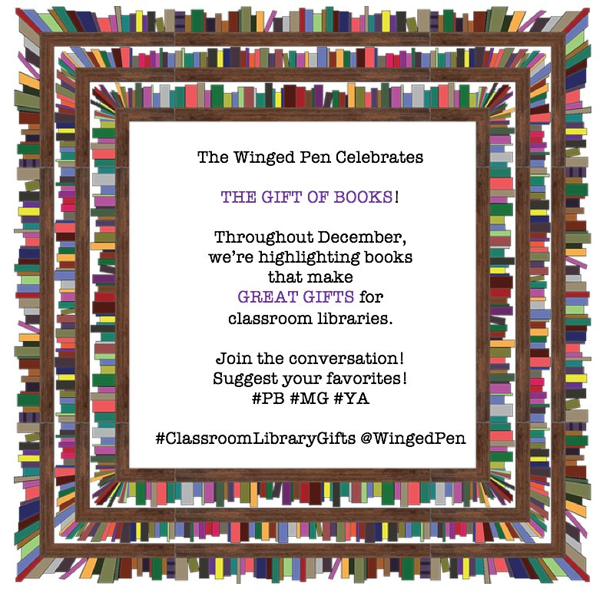
Visit TheWingedPen for more about 10 favorite middle grade titles. Happy Reading!

Pick #1 Giant Squid #NF #PB by @candacemfleming
Pick #2 Wish #MG by @barbaraoconnor
Pick #3 Serafina and the Black Cloak #MG by @BeattyAuthor
Pick #4 The 7th Wish #MG by @KateMessner
Pick #5 The Adventurer's Guide to Successful Escapes #MG by @wadealbertwhite
Pick #6 Summerlost #MG by @allycondie
Pick #7 The Absolute Value of Mike #MG by @ValueOfMike Kathryn Erskine
Pick #8 The Last Cherry Blossom #MG by @klburkinshaw1
Pick #9 Booked and The Crossover #YA by @kwamealexander
Pick #10 A Monster Calls #YA by @Patrick_Ness
Pick #11 What Do You Do With A Tail Like This? #PB by Steve Jenkins
Pick #12 El Deafo #MG by @CeceBellBooks
Pick #13 Savvy #MG by @Author_ing Ingrid Law
Pick #14 Ophelia and the Marvelous Boy #MG by @karenfoxlee
Pick #15 The Honest Truth #MG by @DanGemeinhart
Pick #16 Brown Girl Dreaming #MG #verse by @JackieWoodson
Pick #17 The Girl Who Drank the Moon #MG by Kelly Barnhill
Pick #18 George #MG by @lxgino
Pick #19 Rules for Stealing Stars #MG @CoreyAnnHaydu
Pick #20 Ghost #YA @JasonReynolds83
Pick #21 Between Shades of Gray #YA by @RutaSepetys
Pick #22 A Ticket to the Pennant #PB by @holtzymook
Pick #23 I Want To Eat Your Books #PB by @karinlefranc
Pick #24 Beautiful #PB by @stacymcanulty
Pick #25 One Crazy Summer #MG by Rita Williams-Garcia@OneCrazyRita
Pick #26 Hoodoo #MG by Ronald L Smith @RonSmithbooks
Pick #27 Fish in a Tree #MG by @LynMullalyHunt
Pick #28 Al Capone Does My Shirts #MG by @choldenko
Pick #29 Jumbies #MG by @TraceyBaptiste
Pick #30 Some Kind of Happiness #MG by @clairelegrand
Pick #31 Awkward #MG by @svetlania
Pick #32 Simon Vs. The Homo Sapiens #YA by @beckyalbertalli
Pick #33 Tea Cakes for Tosh #PB by Kelly Starling Lyon @kelstarly
Pick #34 Ada Twist, Scientist #PB by @andreabeaty
Pick #35 Princess Academy #MG by @haleshannon
Pick #36 Like Magic #MG by @ElaineBVickers
Pick #37 The Great Unexpected #MG by Sharon Creech @ciaobellacreech
Pick #38 Roller Girl #MG #GraphicNovel by Victoria Jamieson @JamiesonV
Pick #39 Wolf Hollow #MG by @LaurenWolkBooks
Pick #40 Blue Birds #MG #verse #historical by @CStarrRose
Pick #41 Tesla's Attic #MG by @NealShusterman
Pick #42 Believarexic #YA by @JJJohnsonAuthor
Pick #43 Last Stop on Market Street #PB by @mattdelapena
Pick #44 My Seventh-Grade Life in Tights #MG by @brooksbenjamin
Pick #45 The Last Fifth Grade of Emerson Elementary #MG #verse by @LauraShovan
Pick #46 The Secret Horses of Briar Hill #MG by @megan_shepherd
Pick #47 Sunny Side Up #MG #GraphicNovel by @jenniholm
Pick #48 When the Butterflies Came #MG by Kimberly Griffiths Little
Pick #49 The London Eye Mystery #MG by Siobhan Dowd
Pick #50 March #GraphicNovel Trilogy #YA @repjohnlewis @MARCHTrilogy @andrewaydin
Pick #51 The First Time She Drowned #YA by @kkletter
Pick #52 Lily and Dunkin #YA by @DGephartWrites
Pick #53 Any #PB by @joshfunkbooks
Pick #54 A Mango-Shaped Space by Wendy Mass @wenmass
Pick #55 THE GREAT AMERICAN WHATEVER #YA by @TimFederle
Pick #56 Stalking Jack the Ripper #YA by @KerriManiscalco
Pick #57 Counting Thyme #MG by @MLConklin
Pick #58 How Things Work #MG #NF by @TJResler
Pick #59 Echo #MG by @PamMunozRyan
Pick #60 The Secret Lives of Princesses #PB by Philippe Lechermeier
Pick #61 Destiny, Rewritten #MG by @KFitzmaurice
Pick #62 Unusual Chickens for the Exceptional Poultry Farmer #MG by Kelly Jones @curiosityjones
Pick #63 Thomas and the Dragon Queen #MG by @Shutta Crum
Pick #64 Hope Was Here #MG by @joan_bauer
Pick #65 Nuts to You #MG by Lynne Rae Perkins @GreenwillowBook
Pick #66 Pax #MG by @sarapennypacker
Pick #67 The Sun is Also a Star #YA by @NicolaYoon
Pick #68 This Girl is Different #YA by @JJJohnsonAuthor
Pick #69 OCD Love Story #YA by @CoreyAnnHaydu
Pick #70 The Hundred Lies Of Lizzie Lovett #YA releases 1/3/17 by @chelseasedoti
Pick #71 The Six of Crows #YA by @LBardugo
Pick #72 The Lockwood & Co Series #YA by @JonathanAStroud
Pick #73 Emmanuel's Dream #PB by @LaurieThompson
Pick #74 Just Like Me #MG by @NancyJCavanaugh
Pick #75 Absolutely, Almost #MG by @lisagraff
Pick #76 Be Light Like A Bird #MG by @Monika_Author Monika Schröder
Pick #77 Counting by Sevens #MG by @HGoldbergSloan
Pick #78 The Meaning of Maggie #MG by @MeganJeanSovern
Pick #79 Be A Changemaker #NF #YA by @LaurieThompson
Pick #80 Everything, Everything #YA by @NicolaYoon
Pick #81 This is Where it Ends #YA by @mariekeyn
Pick #82 The Winner's Curse #YA by Marie Rutkoski @WinnersCursePH
Pick #83 All Four Stars #MG by @TaraDairman
Pick #84 A Handful of Stars #MG by @Cynthia_Lord
Pick #85 Tuesdays at the Castle #MG by @JessDayGeorge
Pick #86 Kizzy Ann Stamps #MG by Jeri Watts
Pick #87 I Lived On Butterfly Hill #MG by Marjorie Agosin
Pick #88 Shadowshaper #YA by @djolder
Pick #89 Dream Things True #YA by @MarieFMarquardt
Pick #90 The Perilous Journey of the Not-So-Innocuous Girl series #Steampunk #YA by @LeighStatham
Pick # 91 If You Could Be Mine #YA @SaraFarizan
Pick #92 The Raven Cycle series #YA by @mstiefvater
Pick #93 Turtle In Paradise #MG by @jenniholm
Pick #94 The Lions of Little Rock #MG by @KristinSLevine
Pick #95 The Hero's Guide to Saving Your Kingdom #MG by @ChristophrHealy
Pick #96 Written In the Stars #YA by Aisha Saeed @aishacs
Pick #97 A Darker Shade of Magic #YA by @veschwab
Pick #98 Dorothy Must Die #YA by @daniellempaige
Pick #99 The Rest of Us Just Live Here #YA by @Patrick_Ness
Pick #100 The Darkest Part of the Forest #YA by @hollyblack

